Self-paced courses in the LMS are designed to allow students to learn independently by accessing the learning materials provided by Cakap. Through this feature, students can study anytime and anywhere without being limited by a fixed schedule.
In a self-paced course, students can access various learning materials such as videos, documents, quizzes, and assignments that have been uploaded by the admin. The learning flow can be set as Full Access, where students can open all materials freely, or Sequential, where students must complete the previous material before accessing the next one.
Self-paced courses may also include intro videos, learning materials, and a final test to evaluate the student’s understanding of the course content. After completing all required materials and passing the final test (if applicable), students will be able to receive a certificate as proof that they have successfully finished the course.
This system provides flexibility for students to learn at their own pace while still ensuring that their progress and completion are properly tracked within the LMS.
Students can access a self-paced course by redeeming a voucher code or by purchasing the course through the Marketplace.
If the student has a redeem code generated by the admin, they can enter the code in the LMS to activate the course. Alternatively, students can buy the course directly from the Marketplace, and once the purchase is successful, the course will automatically appear in their My Class or My Course section in the LMS, where they can start learning.

Purchasing The Course
- Search for the course using the search bar and make sure the course status is shown. If the course appears in the results, select the course to continue.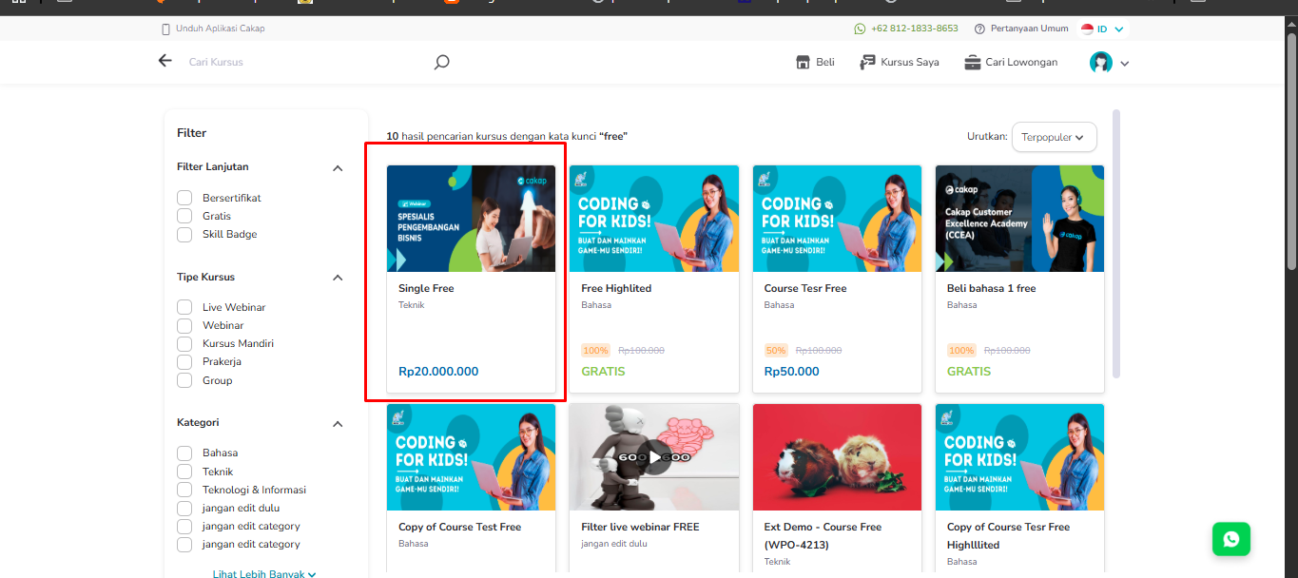
- Click the “Buy Course” button, then you will be redirected to the payment page.
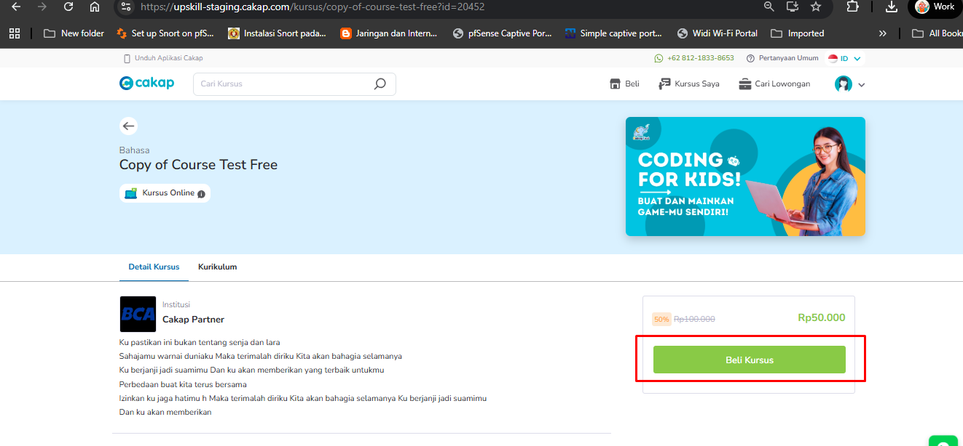

- Choose the payment method. After the payment is successful, the course will be shown in the LMS. Cakap Payment Testing Guide.xlsx

Redeem The Code
- Go to menu kursus saya -> click ‘Tukar’ button -> Input code is has been generate from admin.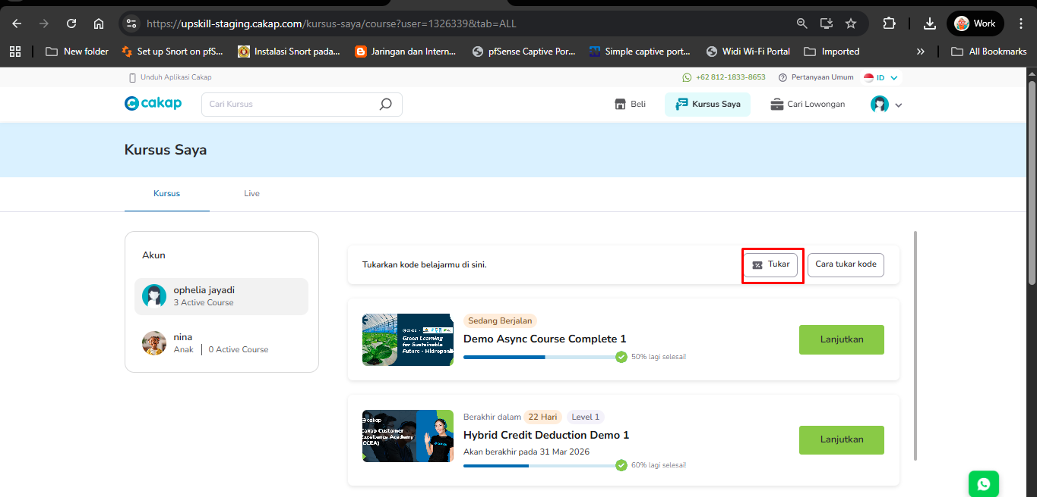
- After success redeem course will be showing in LMS.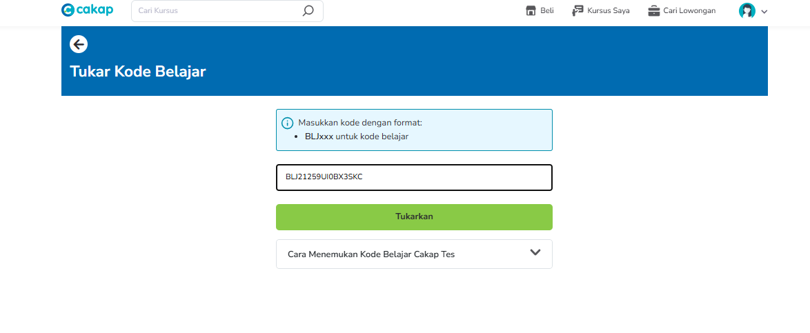
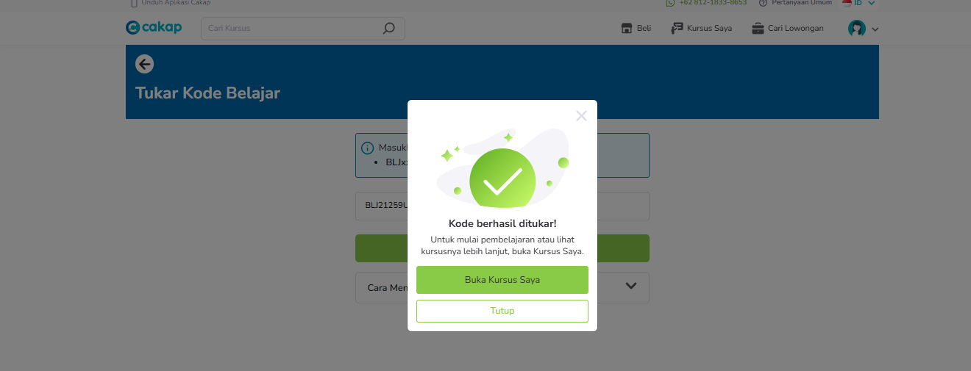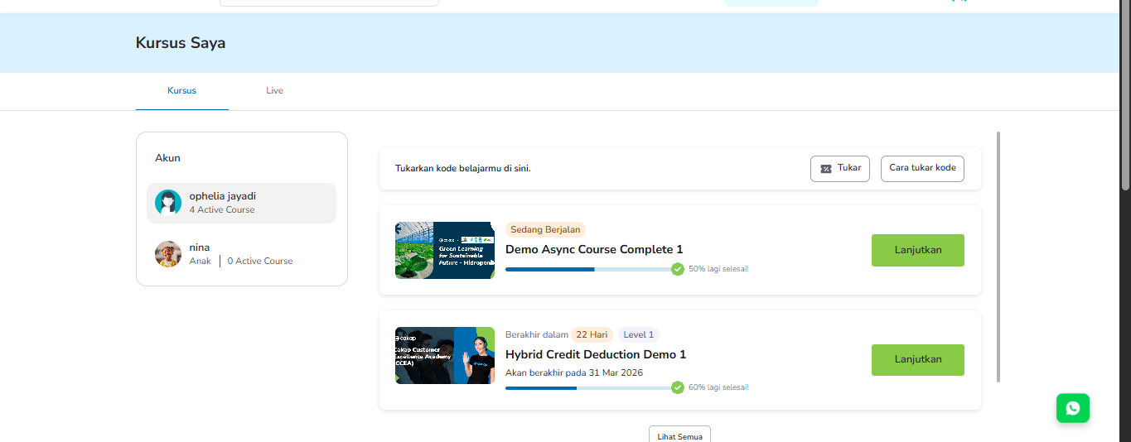

LMS Access
- After a successful purchase or redeem, students can access the class through the My Class menu. Click the “Start” button, then select the material you want to access.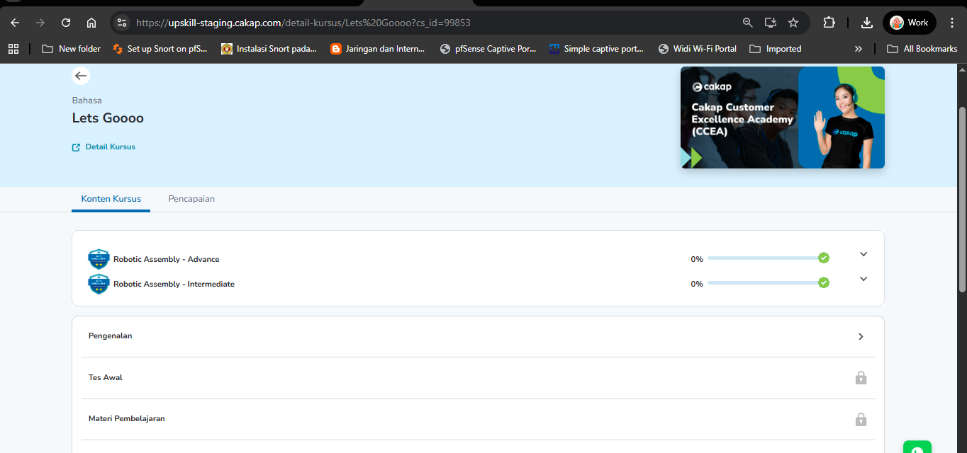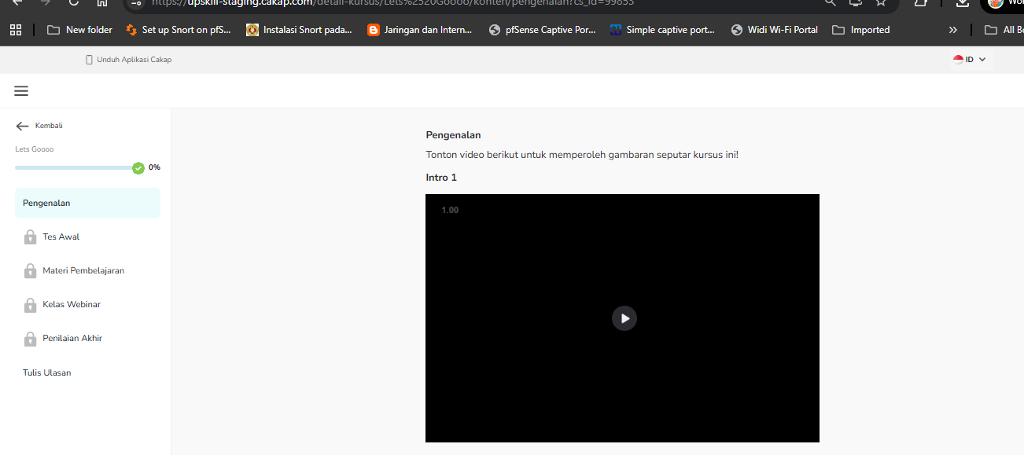

- Students can receive a certificate after completing all learning materials and finishing the quiz.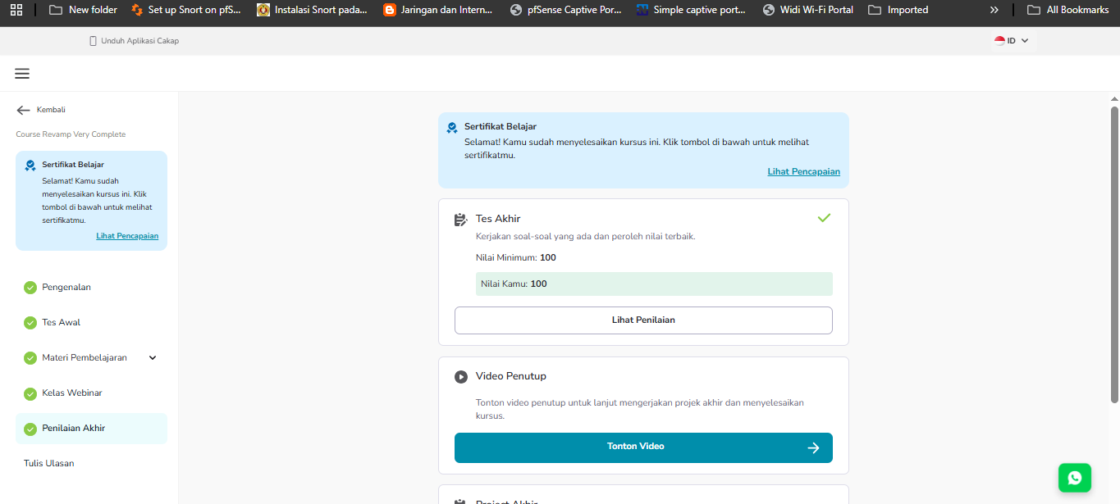
LMS Case
- If the LMS course includes a Daily Report, the teacher is required to submit a report after each class session to record the student’s progress and class activities.
- If the LMS course includes a Final Exam, the teacher must submit the final exam report in the system after the exam is completed. This report is used to record and evaluate the student’s final performance.
- If the LMS course includes a Final Placement Test Report, the teacher also needs to submit the report to determine the student’s level or placement result based on the test.
- However, if the Final Test supports an automatic Final Quiz, the teacher does not need to submit a report. The student’s score will be generated and displayed automatically in the system after the student completes the quiz.

